23CSE202 DATABASE MANAGEMENT SYSTEMS
S3 B.Tech CSE
Department of Computer Science and Engineering
Amrita School of Computing, Amritapuri Campus

02. UI DESIGN

Group No : C3
Team Members :
Roll No | Student Name
Am.sc.u4cse25253 | Sujeeth S
Am.sc.u4cse25239 | Nithish Kumar S
Am.sc.u4cse25262 | Nithilan S
Am.sc.u4cse25259 | Yaksh Chouhan

Project Title :
E-Commerce Database Management System

2.1. Functional requirements:
[list the main functionalities required]
- User Authentication: Registration, login, and logout.
- Product Display: View product details, prices, and stock.
- Product Search and Filtering: Search products and filter by category.
- Cart Management: Add, remove, and update cart items.
- Cart Summary: Calculate and display the total price.
- Checkout: Review items and place orders.
- Order Confirmation: Display order status and details.
- Role-Based Navigation: Provide relevant pages for customers and administrators.
- API Communication: Exchange data with the backend.
- Error Handling: Display validation errors and operation status messages.

2.2. Non functional requirements:
[list the main qualitative features required]
- Usability: The interface should be simple, intuitive, and easy to navigate for all users.
- Responsiveness: The website should adapt to different screen sizes, including desktops, tablets, and mobile devices.
- Performance: Pages, product listings, images, and interactive elements should load and respond quickly.

2.3. List of AI tools used for building UI(if any):
1. Claude
2. Chatgpt

2.5. List of files:
[list the html / JSP/ Java / Python/ any files created for UI]
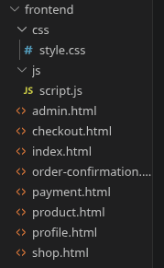
2.6. UI Screenshot:
[give the screenshot of the UI]
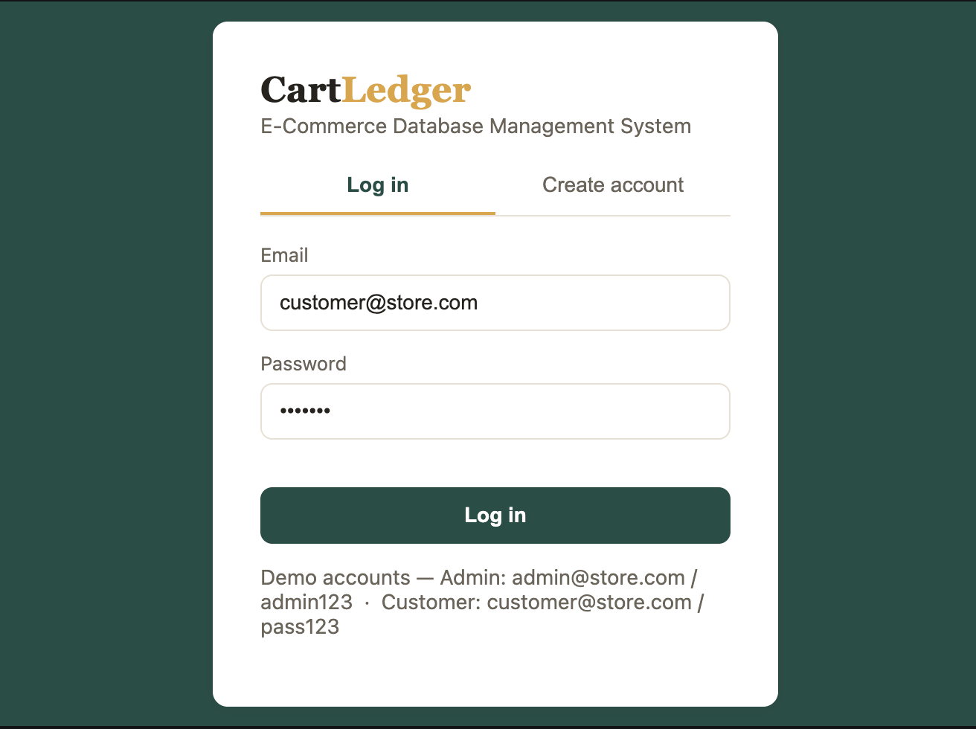

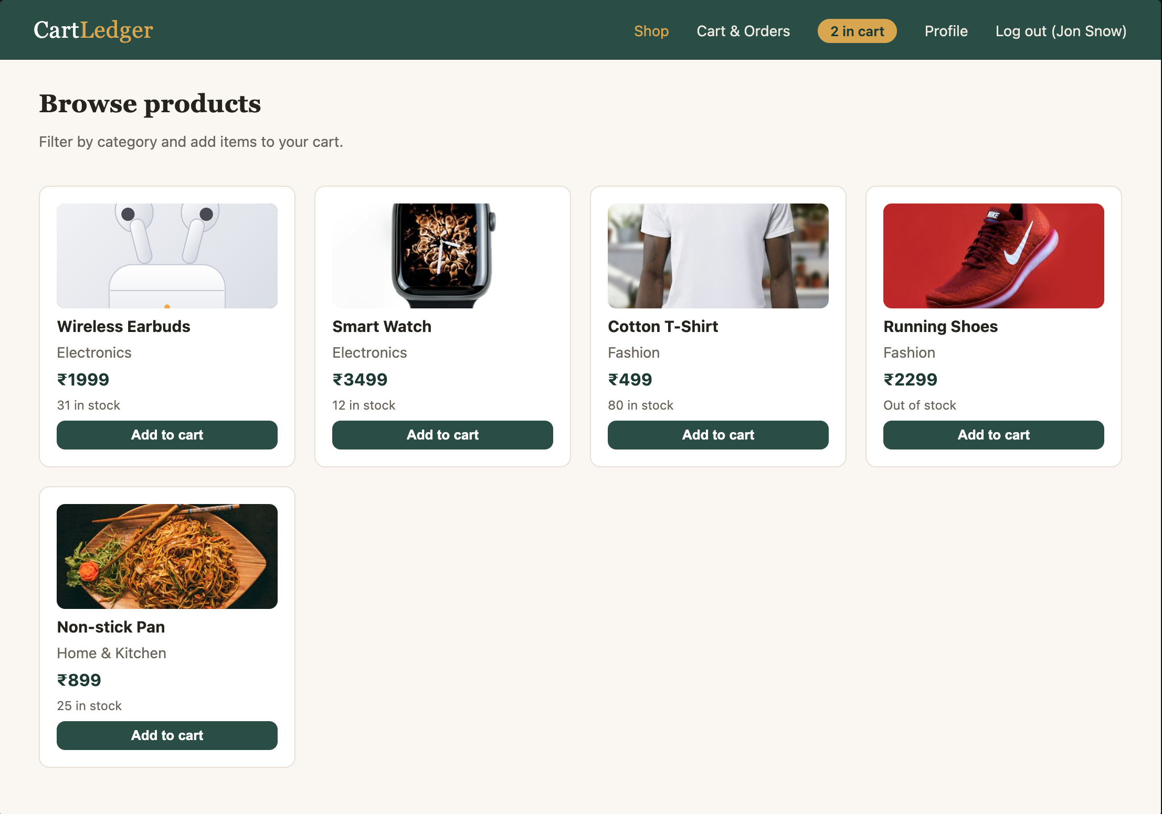
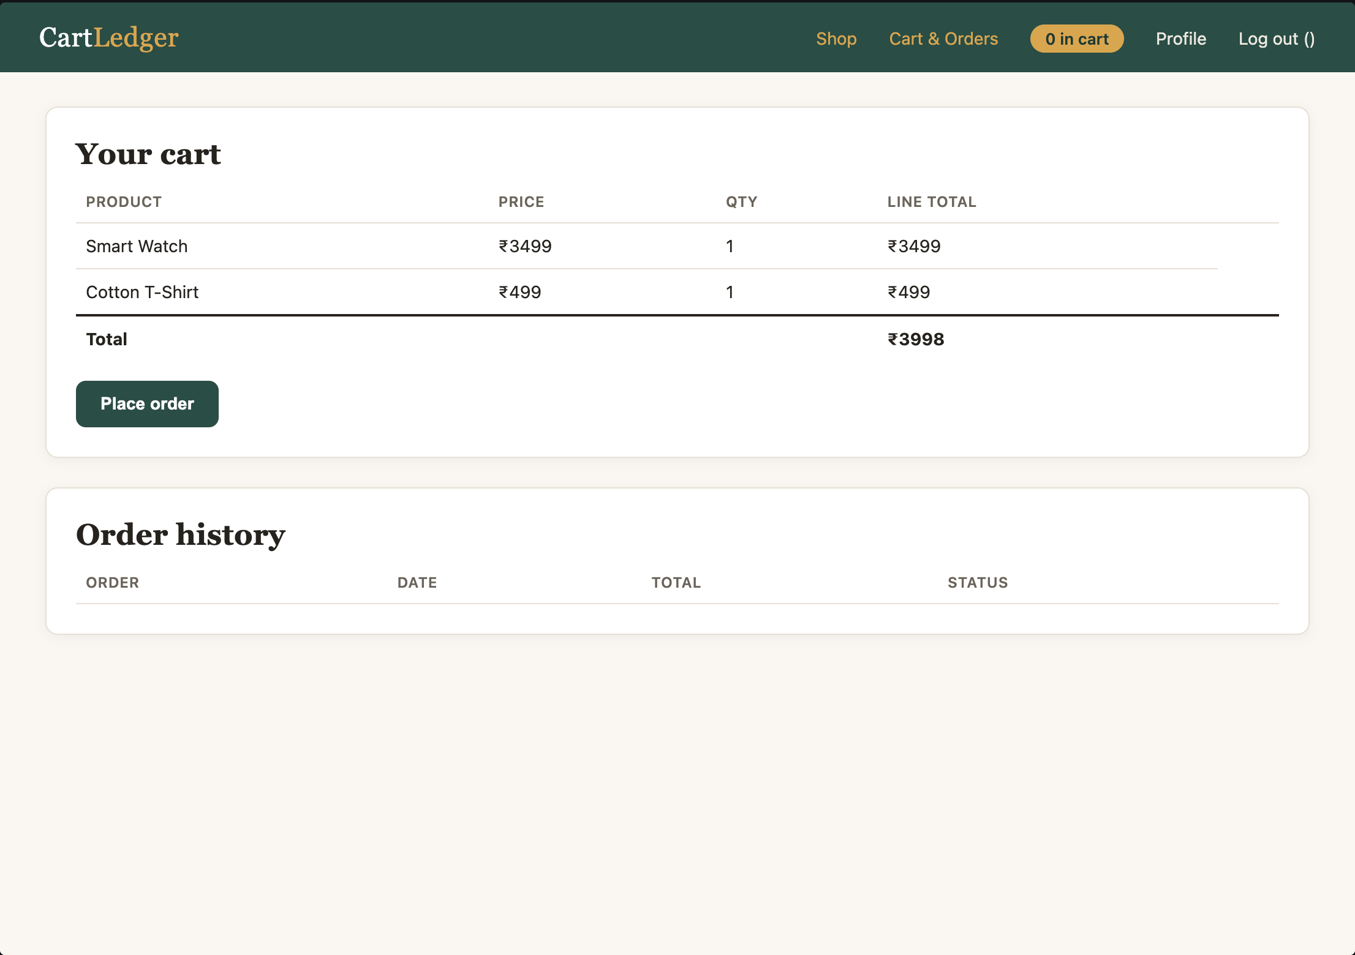

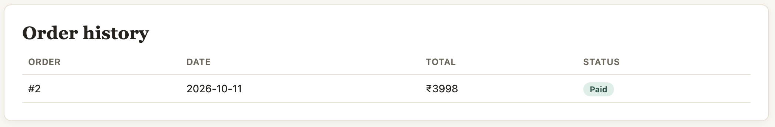

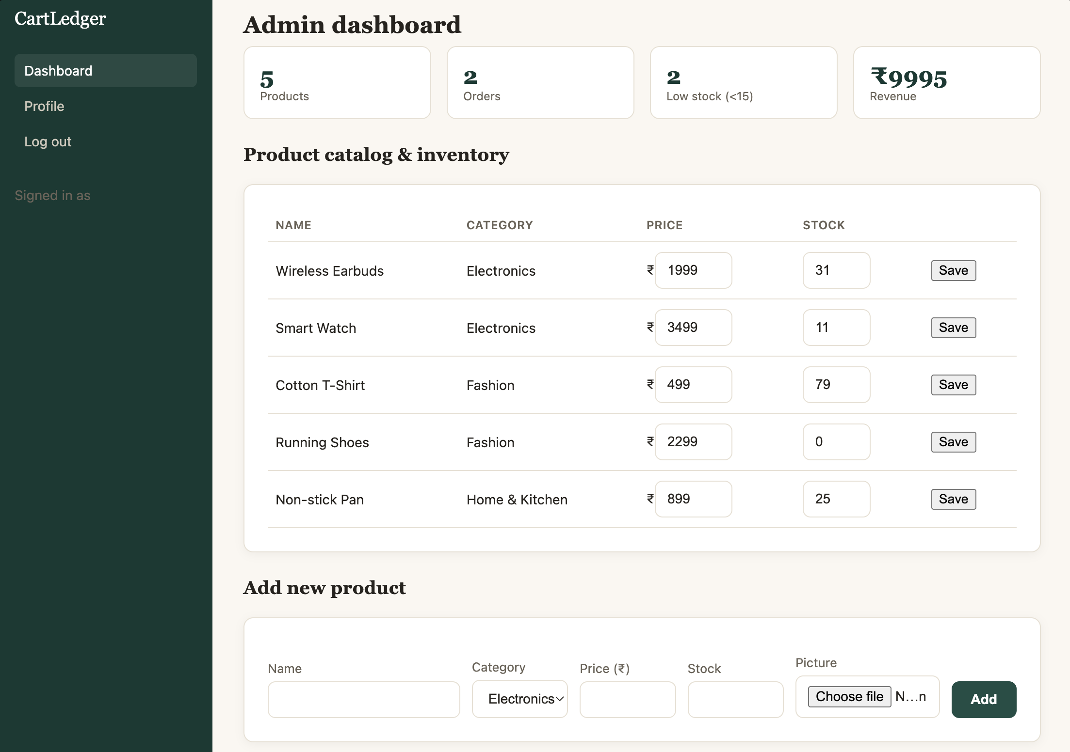
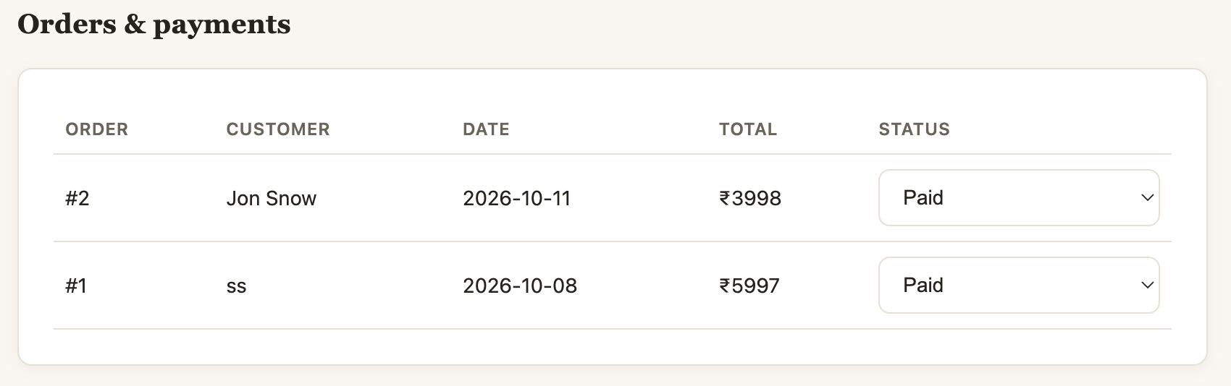

2.7. GitHub Link:
https://github.com/sujeeth2709/Ecom-Sem3

